Analysis of Macroeconomic Variables on Bond Risk Premia

Group members: Chenghao Zhu, Hanqing Zhang, Yufei Wang,

Yuxuan Zhou, Haoyang Shang, Yiming Ding

1 Introduction

The interest rate and the excess return rate in the bond market have always been important, and there are a large number of related theories and empirical analysis documents. Fama and Bliss conducted empirical research on the U.S. bond market and found that forward interest rates can predict changes in interest rates and bond returns. Cochrane and Piazzesi found that: making full use of the information on the term structure of interest rates can improve the ability to predict bond returns; at the same time, in the US bond market, using information on some common macroeconomic variables may also improve the ability to predict bond returns.

2 Notation

|  |  |
| --- | --- |
| Variables | Definitions |
|  | log price of n-year discount bond at time t |
|  | The return on an x-year discount bond bought at time t and sold at t + x |
|  | log yield, |
|  | log forward rate at time t, |
|  | log holding period return at time t+1, |
|  | excess log returns, |

3 Previous models

3.1 Forward Rate Model

Cochrane and Piazzesi study time variation in expected excess bond returns. They run regressions of one-year excess returns at time t+1 on forward rates at time t. And they find that a single factor which is named as the return-forecasting factor, predicts excess returns on one-year to five-year maturity bonds with up to 0.44. The model is constructed as follows:

We use the data from 1964 to 2003 to run regressions of excess returns on all forward rates and the results, the slope coefficients are shown in Table 1 . Our results are very close to Cochrane and Piazzesi, and that’s true: The same function of forward rates forecasts holding period returns at all maturities. Longer maturities just have greater loadings on this same function.

**Table 1：Regressions of Excess Returns on Forward Rates**

|  |  |  |  |  |  |  |  |  |
| --- | --- | --- | --- | --- | --- | --- | --- | --- |
|  |  | |  | |  | |  | |
|  | coef | t | coef | t | coef | t | coef | t |
| const | -0.01 | -4.538 | -0.014 | -3.633 | -0.020 | -3.790 | -0.027 | -3.945 |
| y1 | -0.672 | -5.928 | -1.179 | -5.710 | -1.724 | -6.125 | -2.158 | -6.149 |
| f(2,1) | 0.130 | 0.573 | -0.365 | -0.882 | -0.393 | -0.697 | -0.347 | -0.493 |
| f(3,2) | 0.740 | 3.959 | 2.128 | 6.241 | 2.259 | 4.862 | 2.402 | 4.145 |
| f(4,3) | 0440 | 3.199 | 0.703 | 2.803 | 1.737 | 5.081 | 1.852 | 4.347 |
| f(5,4) | -0.480 | -4.447 | -1.067 | -5.421 | -1.602 | -5.973 | -1.426 | -4.263 |
|  | 0.215 | | 0.224 | | 0.253 | | 0.231 | |

Then we use a single factor to describe expected excess returns, as follows:

The estimate of is obtained by regression of the average excess return on all forward rates,

,

,

The estimate of is obtained by running the four regressions:

,

Table 2 shows the results of the above regressions:

, **b**.

The value of **b** is similar to the paper, but the estimate of is a little different.

**Table 2：Estimate of Single-Factor Model**

|  |  |  |  |  |  |  |  |  |  |  |  |
| --- | --- | --- | --- | --- | --- | --- | --- | --- | --- | --- | --- |
|  | | coef | | | std err | | t-value | | | P>|t| | |
| const | | -0.058 | | | 0.016 | | -3.648 | | | 0.000 | |
| y1 | | 0.804 | | | 0.472 | | 1.703 | | | 0.091 | |
| f(2,1) | | -2.571 | | | 0.987 | | -2.606 | | | 0.010 | |
| f(3,2) | | 0.097 | | | 1.037 | | 0.094 | | | 0.926 | |
| f(4,3) | | 1.988 | | | 0.717 | | 2.771 | | | 0.006 | |
| f(5,4) | | 1.082 | | | 0.595 | | 1.820 | | | 0.071 | |
|  | | 0.162 | | |  | | Adj. R-squared | | | 0.135 | |
|  | coef | |  | coef | |  | | coef |  | | coef |
| const | 0.0007 | | const | 0.0009 | | const | | -0.0002 | const | | -0.0014 |
|  | 0.4412 | |  | 0.8410 | |  | | 1.2510 |  | | 1.4668 |
|  | 0.203 | |  | 0.219 | |  | | 0.251 |  | | 0.229 |

*Notes:* We use overbars to denote averages across maturity, and use hats to denote predictive value.

We also use the data to run Fama-Bliss Regressions:

The results are shown in Table 3. By comparing Table 2 and Table 3, is significantly higher in single-factor model.

**Table 3: Fama-Bliss Excess Return Regressions**

|  |  |  |  |  |  |  |
| --- | --- | --- | --- | --- | --- | --- |
| Maturity n |  |  | std err | t-value | P>|t| |  |
| 2 | 0.0013 | 0.8326 | 0.093 | 8.932 | 0.000 | 0.116 |
| 3 | 0.0003 | 1.1285 | 0.117 | 9.638 | 0.000 | 0.132 |
| 4 | -0.0018 | 1.3692 | 0.002 | 10.436 | 0.000 | 0.151 |
| 5 | 0.0014 | 1.0823 | 0.151 | 7.180 | 0.000 | 0.078 |

**3.2 Term Structure Model**

Cochrane and Piazzesi also proposed the yield curve factor according to Term structure models. They decomposed y to “level”, “slope” and “curvature” factors and connect return-forecasting factor to the yield curve. We do as they did: To connect the return-forecasting factor to yield curve models, we estimate Yield Factors, the result is shown in Table 4. According to the estimate of Yield Factors, we plot the loadings of the level, slope, curvature factors of yields in Figure 1.

**Table 4: Estimate of Yield Factors**

|  |  |  |  |  |  |  |  |  |  |  |
| --- | --- | --- | --- | --- | --- | --- | --- | --- | --- | --- |
|  | y1 | | y2 | | y3 | | y4 | | y5 | |
|  | coef | t | coef | t | coef | t | coef | t | coef | t |
| const | 0.000 | 6.656 | -0.001 | -8.804 | 0.000 | 6.656 | 0.000 | 2.374 | 0.000 | 6.656 |
| level | 0.997 | 1995 | 1.012 | 676.8 | 0.997 | 1995 | 0.999 | 741.4 | 0.997 | 1995 |
| slope | -0.517 | -221.3 | -0.212 | -30.35 | -0.017 | -7.206 | 0.263 | 41.73 | 0.483 | 206.9 |
| curve | -0.217 | -42.67 | 0.116 | 7.586 | 0.283 | 55.52 | 0.036 | 2.632 | -0.217 | -42.67 |
|  | 1.000 | | 0.999 | | 1.000 | | 0.999 | | 1.000 | |

*Notes:* level=, slope=y5-y1, curve=

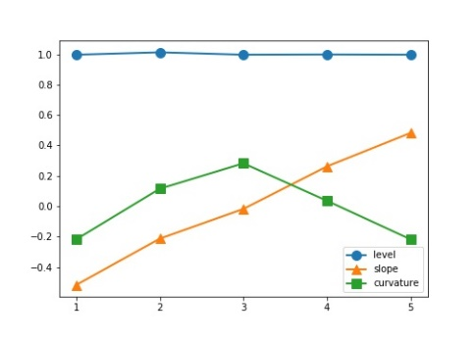

**Figure 1: Yield Factors**

Then we forecast bond excess returns using yield curve factors:

.

The results are shown in Table 5 and Figure 2.

**Table 5: Excess Return Forecasts Using Yield Factors**

|  |  |  |  |  |  |  |
| --- | --- | --- | --- | --- | --- | --- |
|  | y1 | y2 | y3 | y4 | y5 |  |
| none factors | -1.1895  (1.745) | -4.2518  (2.877) | 2.0975  (1.239) | 9.3073  (5.736) | -5.7189  (5.077) | 0.234 |
| level & slope | -2.7074  (4.198) | -4.2600  (2.882) | 2.0893  (1.234) | 9.2991  (5.730) | -4.2172  (5.100) | 0.234 |
| level, slope & curve | -1.1212  (1.693) | -4.2600  (2.882) | -1.0830  (1.328) | 9.2991  (5.730) | -2.6310  (3.446) | 0.234 |

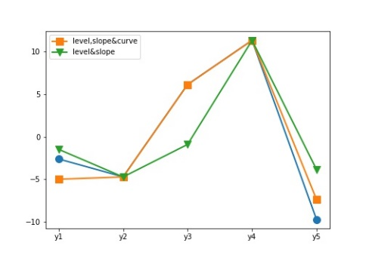

**Figure 2: Return Predictions**

In sum, we forecast bond excess returns using a single factor and yield curve factors. For the results of the model, equals 0.234, which is higher than Fama-Bliss regressions. To help compare models, Figure 3 shows the predictions of different models.

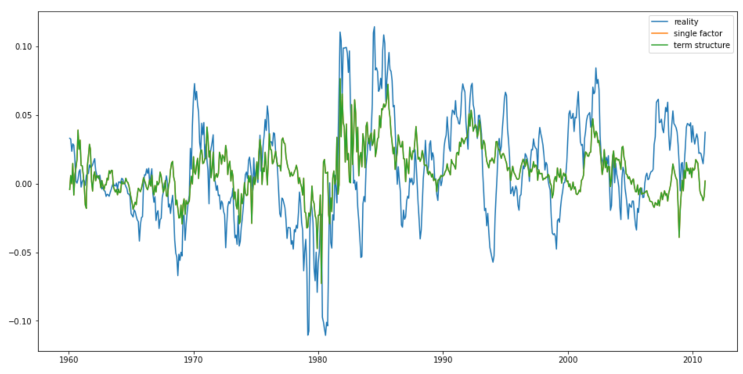

**Figure 3: Forecast and Actual Excess Returns**

4 New Model

4.1 Variable selection and model construction

**4.1.1 A brief analysis of America's macro economy, monetary policy and bond market interest rate**

Ⅰ. The first stage: monetary policy to stimulate economic growth

In the 1930s, the United States experienced the worst economic depression in history. In the process of coping with the crisis, Keynesianism with government intervention as the core has become the leading policy of the United States. This policy orientation lasted until the middle and late 1970s.

Ⅱ. The second stage: the monetary policy with inflation as the main objective stepped on the stage of history

From the mid-1970s to the early 1980s, the stagflation situation in the United States has become increasingly serious. Its CPI reached a high of 12.20% in December 1974.

According to the monetary policy orientation of burns, then chairman of the Federal Reserve from 1970 to 1978, he was still inclined to balance the unemployment rate and inflation. Therefore, in July 1974, the federal funds interest rate of the Federal Reserve began to decline after reaching a high of 12.88%.

In 1978, Miller replaced burns as the chairman of the Federal Reserve. He wanted to stimulate economic growth and control inflation, so that inflation continued to rise. By March 1980, CPI reached a peak of 14.59%.

In 1979, Volcker replaced Miller as the chairman of the Federal Reserve, and the goal of monetary policy was to unilaterally focusing on inflation. The federal fund rate of the Federal Reserve was rapidly increased from 9.42% in June 1980 to the highest point of 19.02% in June 1981 Curbed the rapid rise of CPI: CPI dropped from its peak in March 1980 to 2.36% in July 1983, and since then, the CPI in the United States has not exceeded 6.5%.

Ⅲ. The third stage: monetary policy is dominant, mainly by balancing the inflation rate and economic growth

From the late 1980s to the beginning of 2007, Greenspan served as the chairman of the Federal Reserve for nearly 20 years. During this period, the CPI of the United States has been maintained between 1% and 5%, and the federal funds rate of the Federal Reserve is mainly adjusted, but it is highly forward-looking, that is, faster than the rise of CPI.

Ⅳ. The fourth stage: the monetary policy has reached the extreme, giving birth to unconventional monetary policy

In the period since the outbreak of the subprime mortgage crisis in early 2007, former Federal Reserve Chairman Ben Bernanke focused on economic growth. In line with the quantitative easing policy, the federal funds rate of the Federal Reserve fell to 0.17% in December 2008 and reached an all-time low of 0.54% in December 2016. In this context, GDP growth rate has rebounded.

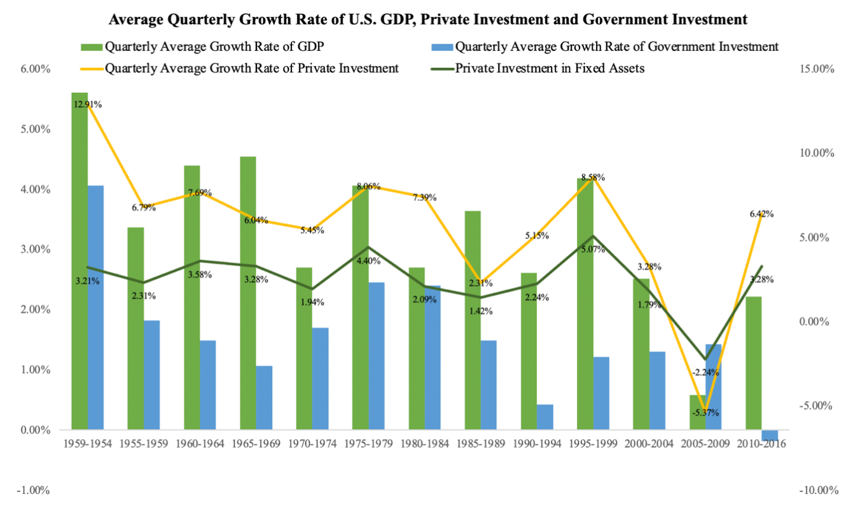

**4.1.2 Influence of economic variables on market interest rates**

It is generally accepted that the adjustment of the official interest rate is passive and lags behind changes in the economic situation, but the official interest rate has great influence on the market interest rate, so how the market interest rate is influenced by economic variables together with the official interest rate is an issue in this paper.

In order to analyze the influence of the official interest rate and the economic variables on the market interest rate, the 1-year deposit rate is used as the official interest rate and is recorded as DR; the growth rates of M1 and M2 of the money supply are used as the other two variables reflecting the monetary policy; the growth rate of real investment (I) and the growth rate of real consumption (C) are used as the variables reflecting the real economy; the growth rate of the factory price index is used as the growth rate of the industrial goods (PPI) and the growth rate of the Consumer Price Index (CPI) as variables reflecting the inflation rate. These variables are shown in Figure 4.

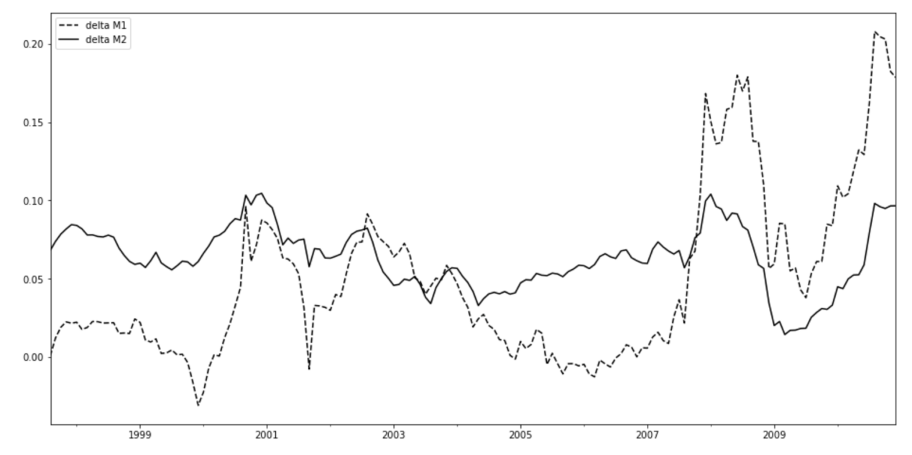

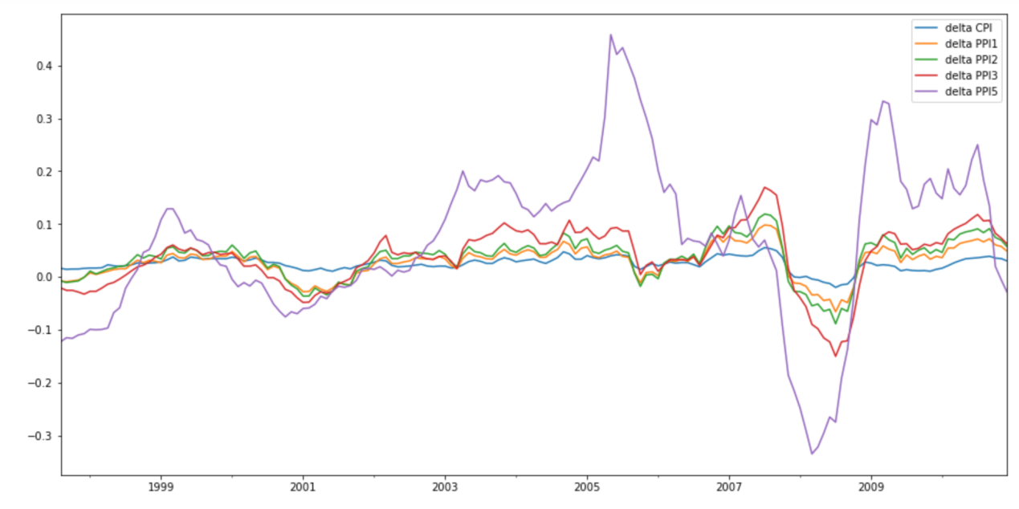

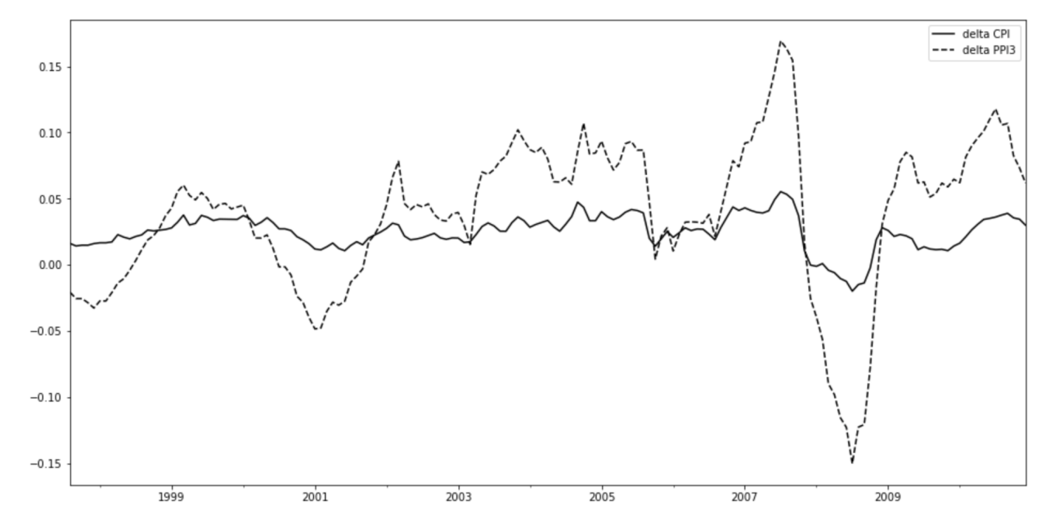

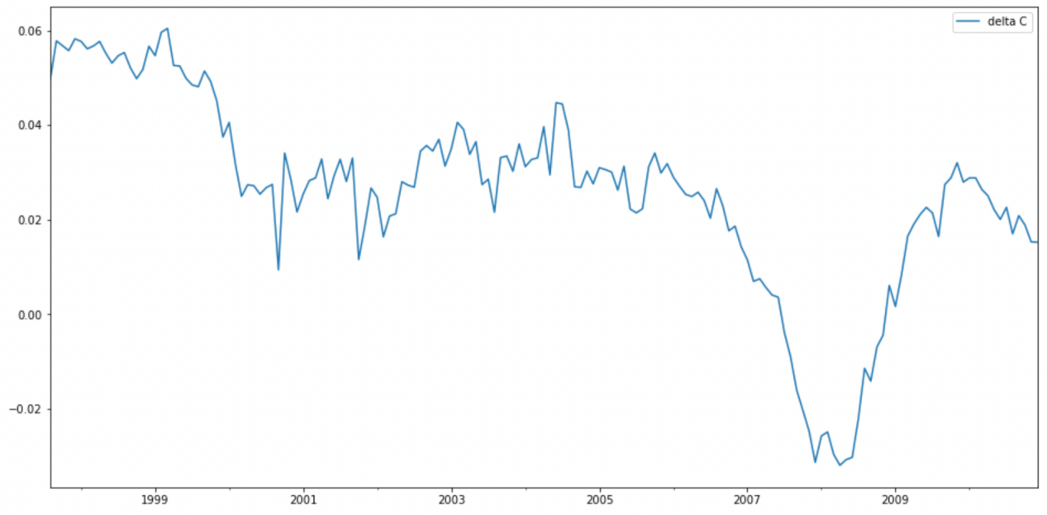

**Figure 4: Trends in Macroeconomic Variables**

Figure 4 shows that the movement of the CPI and the PPI is fairly consistent, with PPI playing a leading role; the volatility of the PPI is greater than that of the CPI. It can also be seen that there is a high correlation between changes in the money supply M1 and the price index. The growth rate of real investment varies considerably, while the growth rate of real consumption varies more rapidly, but not much violently.

The decomposition of variance method is used to reflect the correlation between economic variables, official interest rates and market interest rates. Due to the close relationship between market interest rates of different maturities, the n-year market rate is used as a proxy for the term structure of market interest rates. We construct a vector autoregressive model as follows,

(1)

where X is a vector of macroeconomic variables, monetary policy variables and market interest rates,

**Table 6: Variance Decomposition**

|  |  |  |  |  |  |  |  |
| --- | --- | --- | --- | --- | --- | --- | --- |
|  | CPI | DR | M1 | M2 | PPI | C | Y3 |
|  | C | | | | | | |
| 1 month | 0 | 0 | 0 | 0 | 0 | 100 | 0 |
| 12 months | 0.244848 | 0.001148 | 8.559239 | 7.204886 | 17.83026 | 64.29622 | 1.863406 |
| 60 months | 0.946004 | 0.115646 | 16.16581 | 8.20882 | 16.56401 | 56.12484 | 1.874871 |
|  | CPI | | | | | | |
| 1 month | 74.82341 | 0 | 0 | 0 | 0 | 25.17659 | 0 |
| 12 months | 27.87519 | 11.01885 | 14.01442 | 6.172928 | 26.32314 | 10.79572 | 3.799757 |
| 60 months | 18.14501 | 12.10499 | 23.50926 | 6.585429 | 22.57337 | 13.02139 | 4.060547 |
|  | PPI | | | | | | |
| 1 month | 27.55029 | 0 | 0 | 0 | 71.98937 | 0.460341 | 0 |
| 12 months | 34.71418 | 0.758447 | 5.983408 | 0.053975 | 56.10447 | 1.155634 | 1.229885 |
| 60 months | 21.1702 | 4.85779 | 13.00074 | 3.434966 | 48.94157 | 6.682915 | 1.91182 |
|  | M1 | | | | | | |
| 1 month | 10.03522 | 0 | 86.55638 | 0 | 3.133872 | 0.27453 | 0 |
| 12 months | 14.74062 | 0.360867 | 77.55677 | 0.63327 | 3.020889 | 3.306228 | 0.381349 |
| 60 months | 13.49507 | 6.894527 | 65.1503 | 0.814452 | 9.724536 | 3.274596 | 0.646518 |
|  | M2 | | | | | | |
| 1 month | 3.726813 | 0 | 47.25951 | 29.29475 | 7.320282 | 12.39864 | 0 |
| 12 months | 5.190486 | 7.399283 | 24.06004 | 27.95031 | 16.5273 | 18.6842 | 0.188372 |
| 60 months | 4.096965 | 21.86017 | 15.4688 | 28.83599 | 17.18521 | 12.08359 | 0.469273 |
|  | DR | | | | | | |
| 1 month | 1.674227 | 73.26225 | 6.578802 | 3.045778 | 15.06124 | 0.377703 | 0 |
| 12 months | 1.817047 | 70.79528 | 8.976024 | 3.01138 | 14.51366 | 0.78014 | 0.106474 |
| 60 months | 2.166298 | 63.10602 | 13.35274 | 4.721328 | 13.71132 | 2.488765 | 0.453531 |
|  | Y3 | | | | | | |
| 1 month | 0.055153 | 62.09894 | 3.056151 | 16.20605 | 10.94879 | 0.000615 | 7.634308 |
| 12 months | 1.657813 | 59.84652 | 4.037078 | 14.89018 | 12.55327 | 0.001062 | 7.014082 |
| 60 months | 3.01526 | 57.15404 | 6.477606 | 14.46785 | 11.8809 | 0.369025 | 6.635326 |

According to the likelihood ratio test, we select the lagged order p=4 of the vector autoregressive equation, which is obtained from equation (1) as follows. The results of the variance decomposition are shown in Table 6.

Table 6 gives the proportion of the prediction error for each variable in the short term (t=1), medium term (t=12) and long term (t=60) that is due to variation in its own uncertainty or variation in the uncertainty of other variables. The decomposition of variance reflects the magnitude of the interaction of the individual variables.

From Table 6 it can be seen that, in the short term, uncertain changes in consumption are mainly due to uncertain changes in themselves and have little relationship with other variables. In the medium and long term, prices and the money supply M2 have a certain influence on changes in real consumption.

In the medium to long term, the consumer price index is influenced by the PPI for industrial goods, real consumption and the money supply M1. The PPI is mainly influenced by consumption and investment and the money supply M1. The variables influencing the official interest rate are real consumption and the price index. This means that the official interest rate is set with reference to real consumption and price factors. When consumption is low, the official interest rate may be lowered in order to stimulate consumption. The official interest rate is also set in close relation to the price index. When the inflation rate rises, the official interest rate rises as well.

4.2 Empirical analysis of model

**4.2.1 Analysis of the determinants of excess returns on bonds**

Table 6 already shows that the market interest rate is evidently influenced by official interest rate DRt, price index PPI, money supply M1 and M2, which can be regarded as state variables of economy determining the price and bond yield, (together with the short-term interest rate rt). Considering that DR takes only a few values during a sample period, and also the synchronization between DR and rt, short-term interest rate rt is used as a proxy for DR. Then we choose the key vector of economic state as

The uncertain changes of economic state variables affecting bond prices bring about the risks of bond investments and may play an explanatory role in the excess returns on bonds. In order to analyze whether the excess return on bonds is affected by changes in economic state variables, the following regression is constructed.

(2)

where is the monthly return on bond i (expressed as the nominal annual interest rate), n is the number of variables in the vector Y, Y is the k-th economic state variable and ε is the random error term. We assume that the random errors in different bond returns are independent of each other, but with different variances, and that the random error series of the same bond are not serially correlated. The reason why assumption of random errors is so strict, is to simplify the estimation of equation (2).

**4.2.2 The results of regressions and the explanatory power**

The explanatory power of macro factors for abnormal bond returns. The sample data are from August 1997 to December 2005. The monthly return data of 14 government bonds are used, which have different sample intervals. The sample intervals of the return data are shown in Table the empirical analysis becomes very difficult due to the different sample intervals for different bonds. When estimating equation (2), data at time t is used for rt, but as for the other economic variables, data with a time lag of 2 months is used, because these macroeconomic data are generally published with a lag of one to two months. Therefore, the following equation is actually estimated when estimating equation (2),

(3)

**Table 7: Regressions of New Factors**

|  |  |  |  |  |  |  |  |  |
| --- | --- | --- | --- | --- | --- | --- | --- | --- |
|  |  | |  | |  | |  | |
|  | coef | t | coef | t | coef | t | coef | t |
| const | -0.0082 | -2.068 | -0.0100 | -1.293 | -0.0103 | -0.964 | -0.0074 | -0.556 |
| R(1,t) | 0.1729 | 1.515 | 0.01759 | 0.789 | 0.0523 | 0.169 | -0.0998 | -0.258 |
| PPI | -0.0147 | -0.762 | -0.0160 | -0.423 | 0.0019 | 0.036 | 0.0144 | 0.219 |
| M1 | 0.0954 | 2.353 | 0.1411 | 1.782 | 0.1643 | 1.490 | 0.1839 | 1.337 |
| M2 | 0.1059 | 1.149 | 0.2384 | 1.323 | 0.3900 | 1.555 | 0.4773 | 1.525 |
|  | 0.235 | | 0.177 | | 0.155 | | 0.142 | |

In addition, we extract these four new variables and factored them into the model together with the variables used in the previous article, with results in Table 8.

**Table 8: Regression of All Factors**

|  |  |  |  |  |  |  |  |  |
| --- | --- | --- | --- | --- | --- | --- | --- | --- |
|  |  | |  | |  | |  | |
|  | coef | t | coef | t | coef | t | coef | t |
| const | -0.0456 | -6.184 | -0.088 | -6.117 | -0.1228 | -6.133 | -0.1606 | -6.545 |
| R(1,t) | 0.1603 | 0.79 | 0.2144 | 0.542 | 0.0639 | 0.116 | -0.1302 | -0.193 |
| f(2,1) | -0.6993 | -1.718 | -1.3112 | -1.652 | -1.1653 | -1.055 | -0.5684 | -0.42 |
| f(3,2) | 1.2499 | 2.912 | 1.9889 | 2.378 | 1.0758 | 0.924 | -0.5189 | -0.364 |
| f(4,3) | -0.0105 | -0.367 | -0.0492 | -0.085 | 1.0246 | 1.267 | 1.3994 | 1.412 |
| f(5,4) | 0.3597 | 1.452 | 0.9321 | 1.98 | 1.3855 | 2.115 | 2.7905 | 3.474 |
| PPI | 0.0247 | 1.352 | 0.0573 | 1.61 | 0.0888 | 1.793 | 0.1064 | 1.751 |
| M1 | 0.2003 | 4.857 | 0.3339 | 4.1154 | 0.4151 | 3.711 | 0.4504 | 3.284 |
| M2 | 0.0022 | 0.025 | 0.0534 | 0.315 | 0.1184 | 0.503 | 0.2371 | 0.822 |
|  | 0.418 | | 0.377 | | 0.361 | | 0.373 | |

4.3 Conclusion

From the results from Table 7 and Table 7, we find that the excess return on a bond is highly correlated with the market short-term interest rate. The higher the inflation rate, the higher the excess return. The explanation given by Brandt and Wang is that, as market interest rates are very sensitive to the price index, when the price index rises, investors sense a sudden increase in investment risk and become more risk averse, thus demanding higher returns on bonds. Also, when real consumption growth increases, the excess return on bonds decreases. The empirical analysis also shows that when the growth rate of the money supply increases, the excess return on bonds decreases. It may be because that, if the increase in the money supply comes from a stimulus by the government, which means that the economy will soon enter a new period, then investors are more optimistic. And If the increase in the money supply comes from an increase in consumption or investment, it is also indicated that investors are less risk averse in current economic situation.

To help compare models, Figure 4 shows the predictions of different models again, and we can easily tell that the predicting accuracy of our new model is higher than the single factor model.

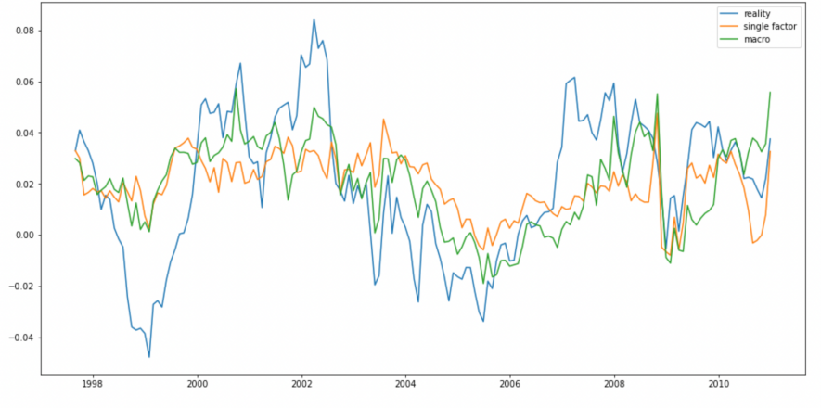

**Figure 4: Forecast and Actual Excess Returns**

**5 Strategy**

Then we intend to form strategies based on previous models and to see whether they can make a profit for investors.

**5.1 Simple Strategy**

We first apply a simple strategy on prediction, which is taking a long position in the bond if the prediction based on previous data shows positive separately, and the results are as follows:

**5.1.1 Two-year bond**

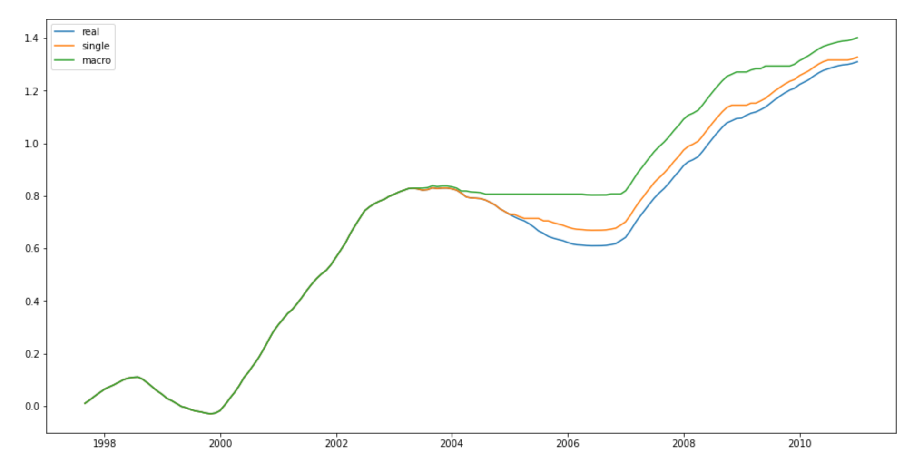

|  |  |  |  |
| --- | --- | --- | --- |
|  | **Annual return** | **Max drawdown** | **Sharpe ratio** |
| **Buy and hold** | 10.02% | -19.85% | 2.14 |
| **Single** | 10.16% | -14.98% | 2.22 |
| **Macro** | 10.78% | -13.10% | 2.51 |

**5.1.2 Three-year bond**

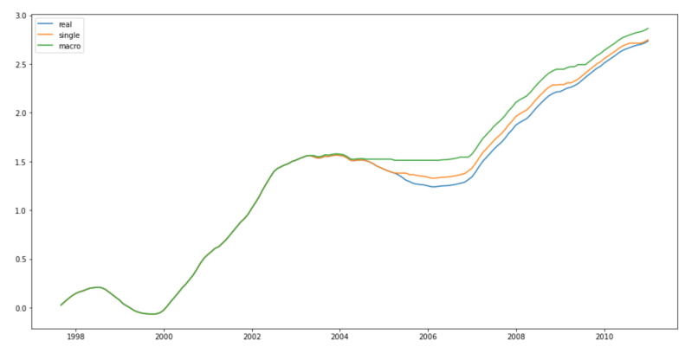

|  |  |  |  |
| --- | --- | --- | --- |
|  | **Annual return** | **Max drawdown** | **Sharpe ratio** |
| **Buy and hold** | 21.73% | -27.90% | 2.37 |
| **Single** | 21.86% | -24.18% | 2.42 |
| **Macro** | 22.95% | -24.18% | 2.66 |

**5.1.3 Four-year bond**

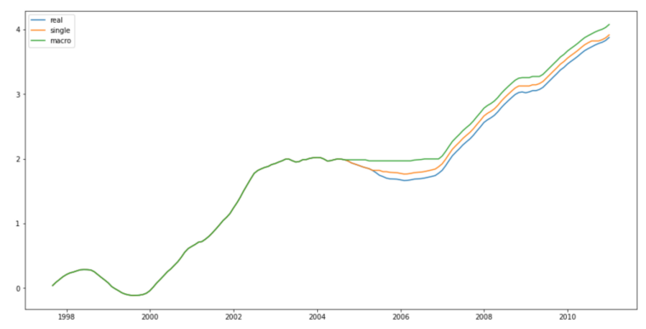

|  |  |  |  |
| --- | --- | --- | --- |
|  | **Annual return** | **Max drawdown** | **Sharpe ratio** |
| **Buy and hold** | 31.79% | -33.48% | 2.44 |
| **Single** | 32.21% | -33.48% | 2.51 |
| **Macro** | 33.83% | -33.48% | 2.72 |

**5.1.4 Five-year bond**

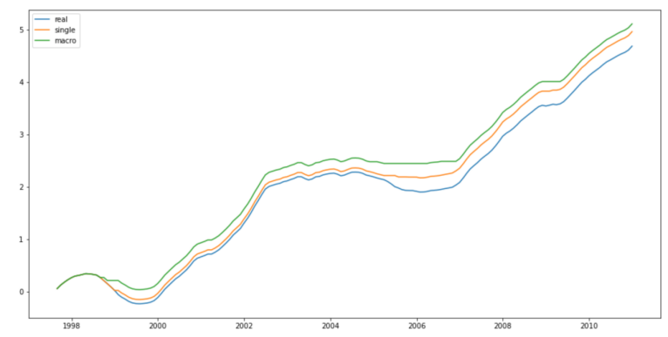

|  |  |  |  |
| --- | --- | --- | --- |
|  | **Annual return** | **Max drawdown** | **Sharpe ratio** |
| **Buy and hold** | 39.14% | -44.60% | 2.38 |
| **Single** | 42.12% | -39.77% | 2.67 |
| **Macro** | 43.80% | -26.76% | 2.90 |

Based on the analysis above, both models can achieve a better performance than the simple buy and hold strategy, and model with macro variable performs even better, with higher annual return and Sharpe ratio.

**5.2 Alternative Strategy**

Then we apply a strategy that takes bonds with different maturities as a whole. Every month, we predict all the bond returns based on previous data, and only taking position in bonds with expected return ranking top 50%.

The line graph and chart below show that both models share similar performance, greatly increasing annual return and improving Sharpe ratio compared with simple buy and hold strategy.

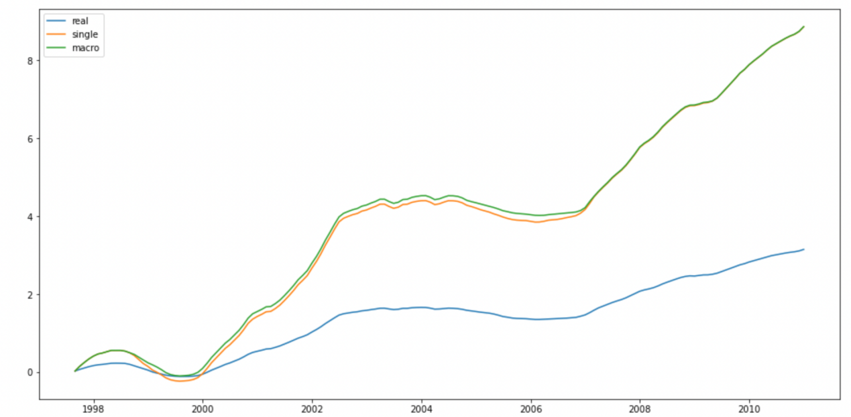

|  |  |  |  |
| --- | --- | --- | --- |
|  | **Annual return** | **Max drawdown** | **Sharpe ratio** |
| **Buy and hold** | 25.32% | -29.26% | 2.40 |
| **Single** | 84.61% | -56.01% | 2.66 |
| **Macro** | 84.98% | -49.14% | 2.74 |

**6 Conclusion**

From the results above, we find that the excess return on a bond is highly correlated with the macro factors, including PPI, M1 and M2, and the predicting model containing these factors share a greater R2 and predicting accuracy than the original forward rate model.

Furthermore, when we put our new model into strategies on real bond market, it shows a greater profitability than previous forward rate model, which can be used as a reference in bond trading.

For the innovation in our project, we try to discover the relationship between macro variables and bond excess return. The decomposition of variance method is used to perform variance decomposition on the initially selected factors. According to the likelihood ratio test, the lag order p=4 of the vector autoregressive equation is selected to obtain the variance decomposition result. The variance decomposition intuitively reflects each variable, and we select 4 more significant factors from these for analysis.

**7 Reference**

[1] Fama E, Bliss R. The information in the long-maturity rates[J].American Economic Review, 1987, 77(4):680-692.

[2] Cochrane J, Piazzesi M. Bond risk premia[J].The America Economic Review, 2005, 95 (1) :138—147.

[3] Sydney C. Ludvigson, Serena Ng. Macro Factors in Bond Risk Premia[J]. The Review of financial studies, 2009, 22(12):5027-5067.

[4] Jonathan H Wright. Term Premia and Inflation Uncertainty: Empirical Evidence from an International Panel Dataset[J]. American Economic Review,2011,101(4).

[5] Michael D. Bauer, Glenn D. Rudebusch, Jing Cynthia Wu. Term Premia and Inflation Uncertainty: Empirical Evidence from an International Panel Dataset: Comment[J]. American Economic Review,2014,104(1).

[6] Cieslak Anna, Povala Pavol. Expected Returns in Treasury Bonds[J]. Review of Financial Studies,2015,28(10).

[7] Hao Zhou. Variance Risk Premia, Asset Predictability Puzzles, and Macroeconomic Uncertainty[J]. Annual review of financial economics, 2018, 10:481-497.